A REFLECTIVE WRITING ON GUARDIAN LEAGUE TABLE ANALYSIS

**BY**

**DEBORAH ADEYEMI**

**21064152**

[**UFCFKR-15-M - BUSINESS INTELLIGENCE AND DATA VISUALIZATION**](https://blackboard.uwe.ac.uk/webapps/blackboard/execute/courseMain?course_id=_341994_1)

**Table of Contents**

1. Introduction…………………………………………………………………………
2. Milestone 1

Data exploration……………………………………………………………

1. Milestone 2

Business requirement and identify stakeholders

1. Milestone 3

Data visualization and answer to business questions

1. Milestone 4

Storytelling around the data……………………………………………….

1. Milestone 5

Recommendation for future improvement and Enhancement

1. Challenges and limitations
2. Reference

**Introduction**

The purpose of this diary is to review and analyse the criteria used by universities to determine how they are being ranked. One major question that needs to be answered is whether or not the ranking is based on the quality of the institution or the quality of the students. Another question is whether the ranking is based on the university’s reputation with other countries. The diary will look to show how UWE is being compared both previously and currently with other universities in the UK. The dataset which was obtained from the National Students Survey was analysed by The Guardian league table has 12 years work of guardian data (The Guardian, 2021). To visualize the dataset, a visualization tool ‘Tableau’ will be used to analyse it and identify the relevant key stakeholders who will be interested in this visualization and lastly, provide some recommendations on how UWE can improve their system in order to go higher in their ranking. The screenshot shown below shows the guardian league table analysis for the UK.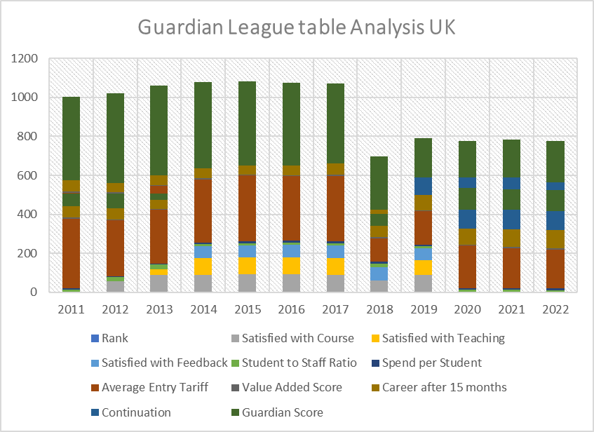***Fig. 1: The guardian league table analysis for UK***

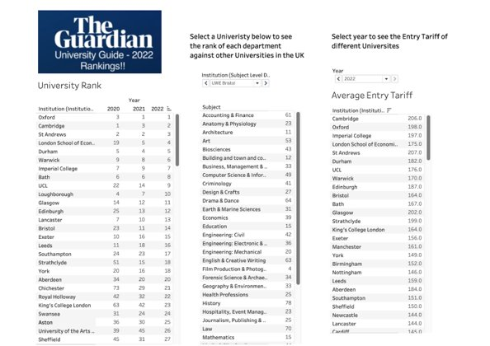***Fig. 2: The guardian university ranking guide***

Before the selection of the topic, the group members asked Dr. Haixia Liu who is the module tutor on a topic to work on and she explained all the topics to the group. During this process, we were told to download and install Tableau on our laptop which will be used for data visualization.

**16TH FEBRUARY 2022 - TOPIC SELECTION**

As a means of communication and sharing data visualizations, I set up a WhatsApp group chat for the group. The team came together to deliberate on which of the projects to work on, and we finally decided to work on Project 1 which is the Guardian League Table Analysis because we would like to know how UWE has been ranked in the whole of England and what the future holds for them. We had a brief meeting on how to start the data visualization and also discussed what the topic is all about.

**17TH FEBRUARY 2022- FIRST INDUSTRY MEETING**

This is the first Industry Advisor meeting with Dan where we were introduced to the topic. It was discussed that we have 3 main league tables which are the complete university guide, time university guide and the guardian. He explained the 12 years of guardian data which was provided for this project.

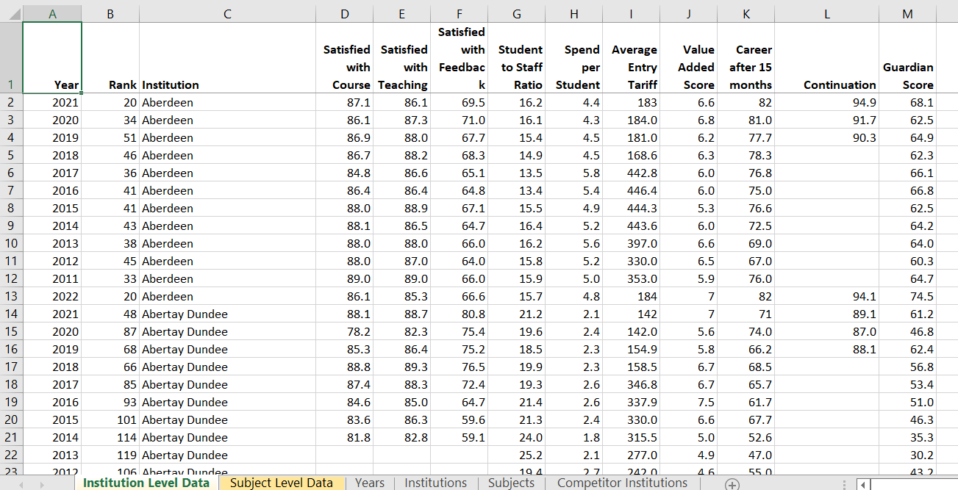

***Fig.3 Dataset to be used for data visualization***

He also discussed about the shortlist and longlist Competitor which will be compared with UWE. I was confused and asked him what’s the difference between the longlist ad the shortlist. He responded by saying shortlist competitors have a lot of shared applications with UWE. This are commonly chosen by student picking UWE and the Longlist are the schools that do not have any relationship with UWE such as University of Bristol.

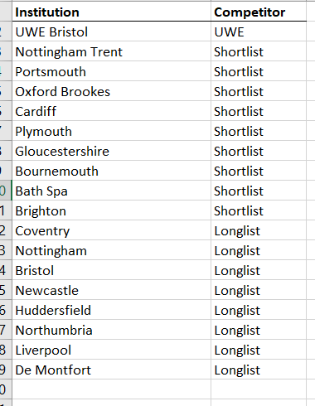

***Fig.4 Shortlist and longlist competitors***

**18TH FEBRUARY 2022 – PERSONAL STUDY**

On this day, I studied the data set where we have the year, rank, institution, satisfied with courses, satisfied with teaching, satisfied with feedback, student to staff ratio, spend per student, career after 15 months, continuation, average tariff and guardian score on the institutional level and the student level. The data as well comprises of the shortlist and longlist competitors. The shortlist competitors are schools that have a lot to share with UWE.

**19TH FEBRUARY 2022 – PERSONAL STUDY – THE GUARDIAN**

I read on how to use the Guardian University guide 2021. If anyone is feeling confused about what and where to study, the university guide will help in choosing (The Guardian, 2021). This made me understand more about what the writeup is all about.

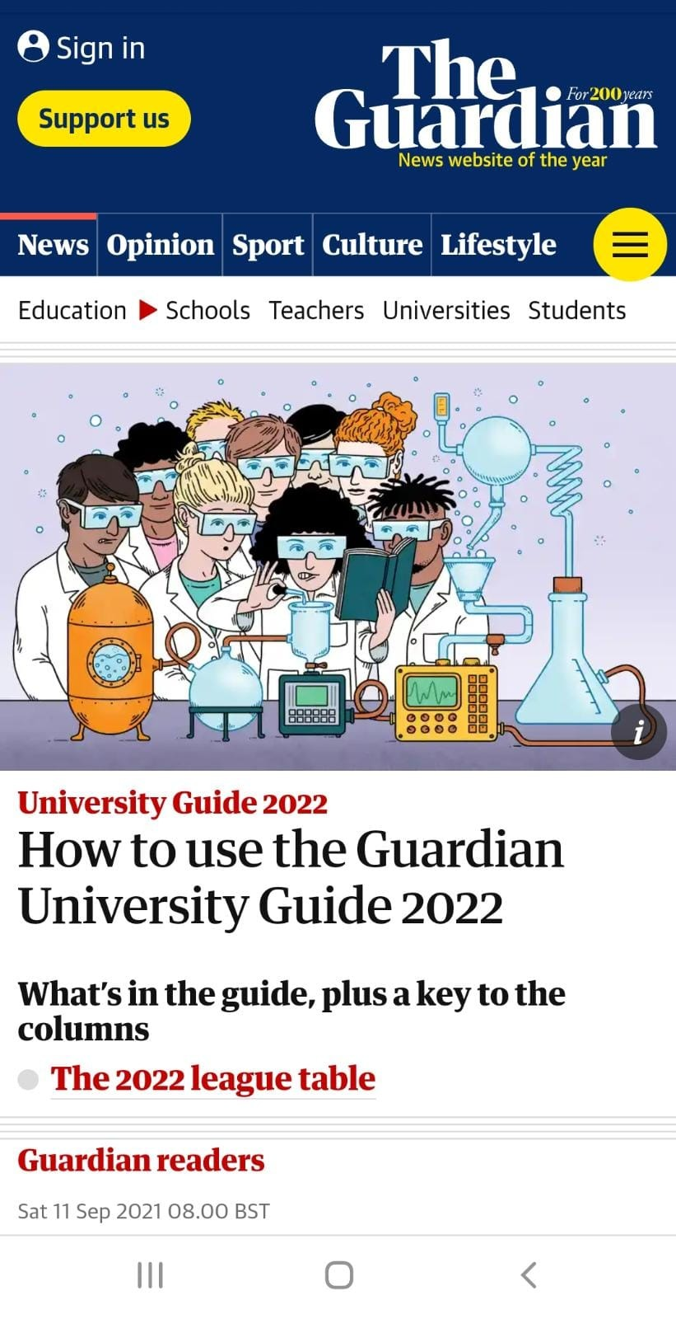

***Fig. 5a: The guardian league***

**20TH FEBRUARY 2022**

I was having difficulty on how to create work sheet on tableau, so I had to watch some YouTube videos on what is tableau by SAF Business Analysis (SAF,2016), how to create a worksheet in Tableau by Mr. Pavan Lalwani. (Pavan,2018) and another by Helpfolder (Helpfolder,2016) and also, how to make connectors of data sources. After watching the video, this helped me with more insights going forward in the project.

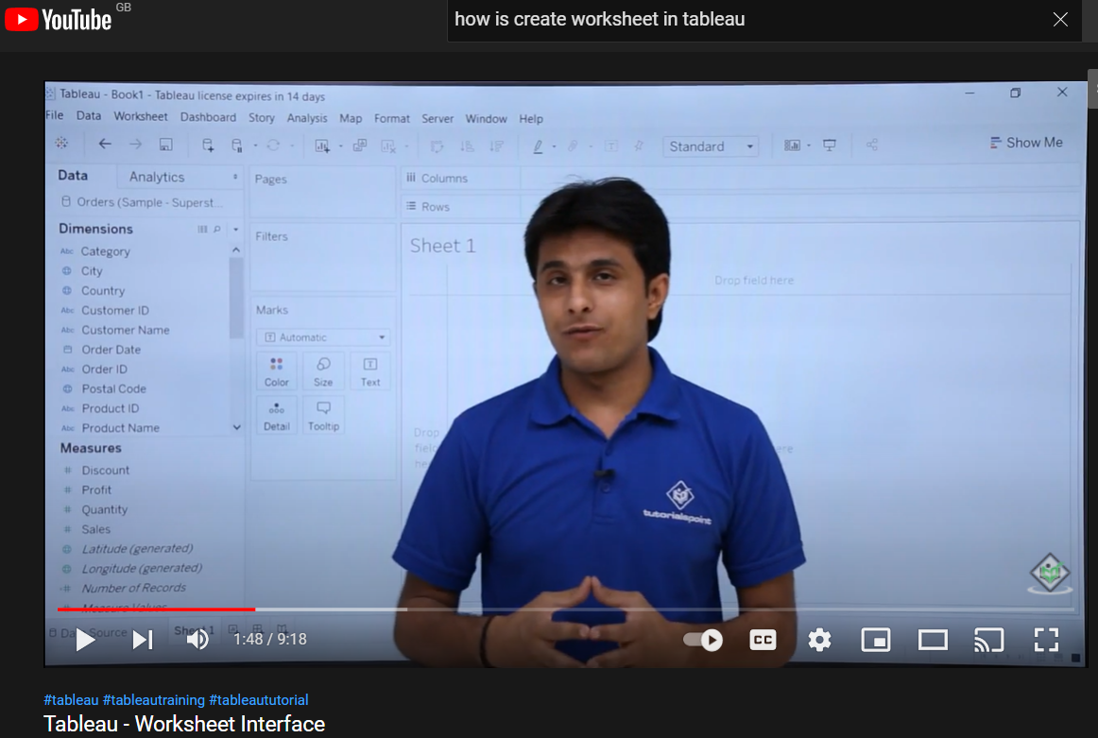

***Fig.5b : Video on how to create worksheet in tableau***

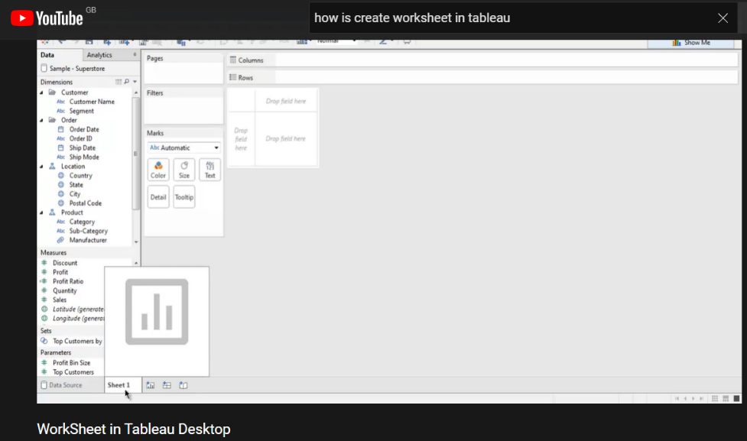

***Fig.6 Processing on how to create worksheet on tableau***

**23RD FEBURARY 2022**

After I studied the dataset and watching videos on YouTube, creating of worksheet and creating connection on Tableau became easy for me. Before creating a worksheet, the dataset file needs to be imported into tableau for connection.

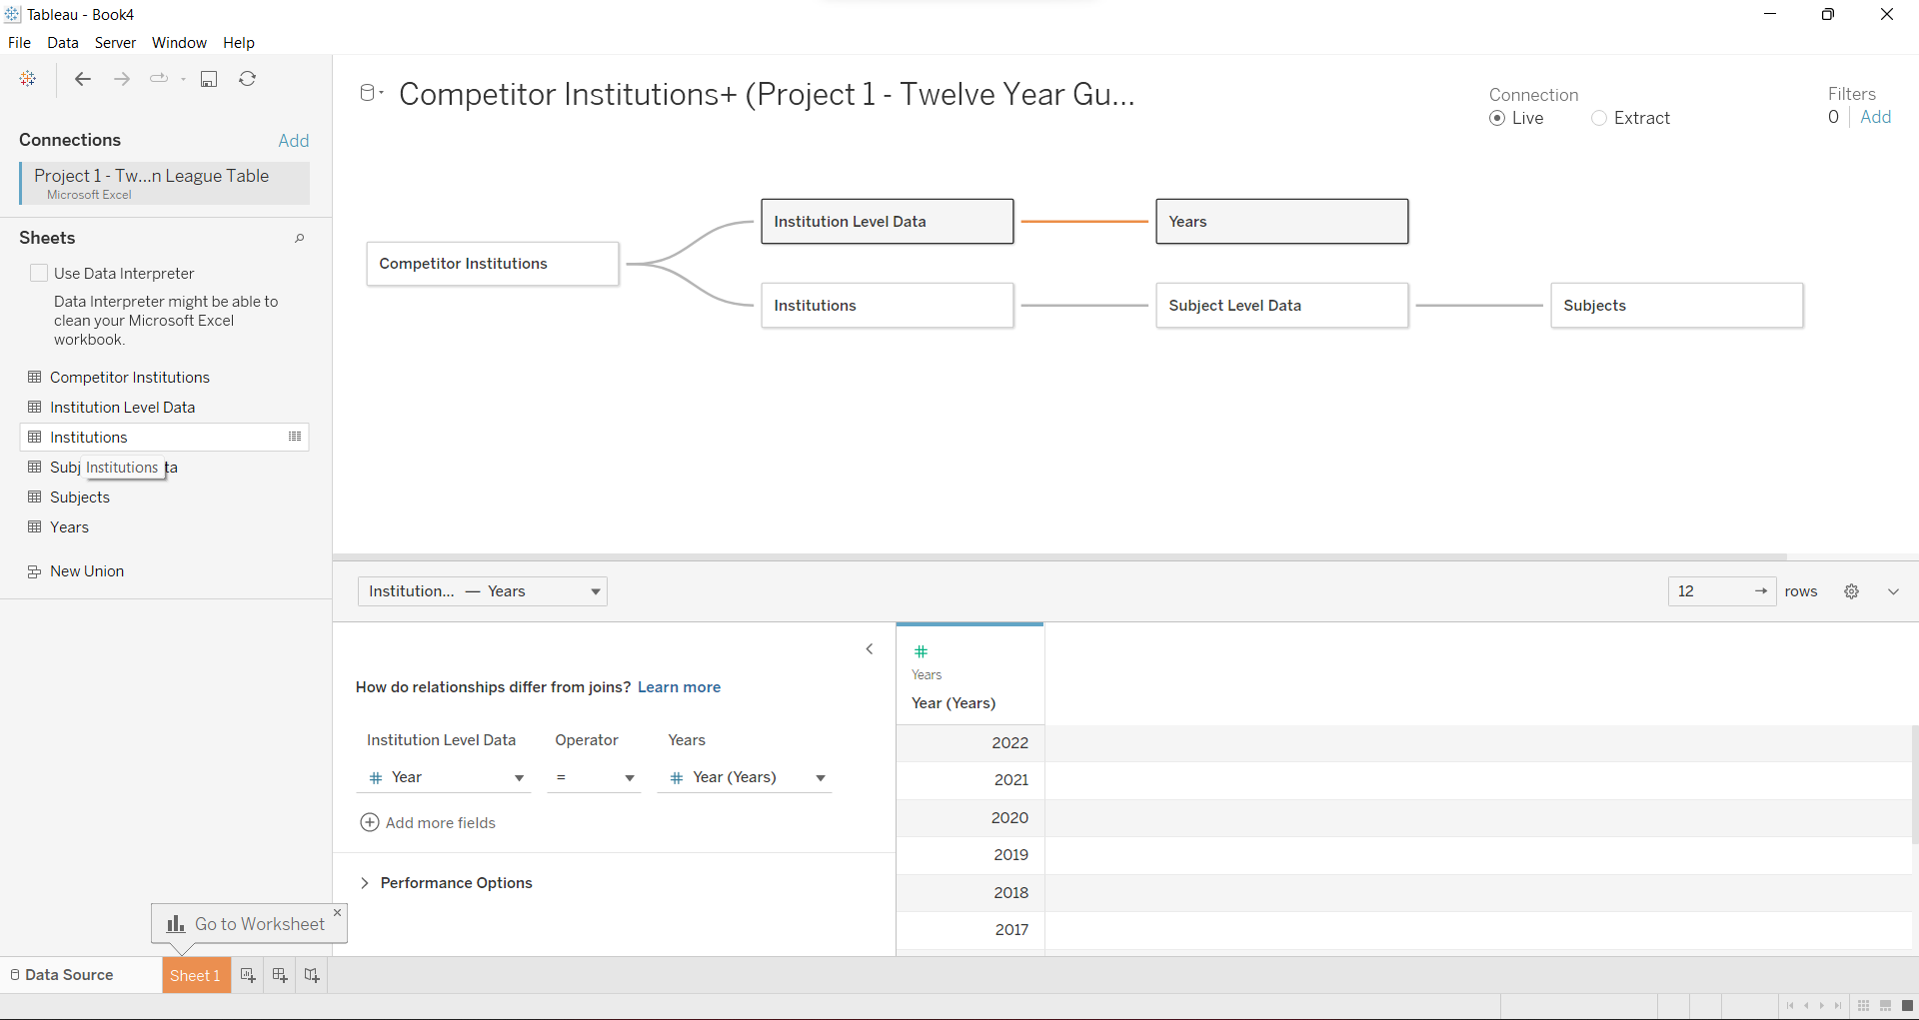

***Fig.7: Connector of data set***

The dataset is connected to each other from the competitor institution to the subjects. This will enable visualize the data in a proper way.

**18TH MARCH 2022 – 2ND INDUSTRY MEETING**

This is the 2nd industry Advisor meeting with Dan. It was discussed that subject and subject level is very important in the guardian league table. He also discussed about the stakeholders, having few colors on our work, and using scatter plot.

**18TH MARCH 2022 – TEAM MEETING**

It was determined that the data is not in need of cleaning any, and even if there was a need for cleaning, it would not affect the data. The group discussed the data after the industry advisor had finished.

**20TH MARCH 2022 – MILESTONE 1**

**Does the dataset need cleaning?**

Data cleaning is essential to data science. It deals with data problems once they have occurred. Error prevention strategies can reduce many problems but cannot eliminate them. However, data cleaning can help eliminate some identifiable abnormalities. Broeck, Cunningham, Eeckels, and Herbst (2005) present data cleaning as a three-stage process, involving repeated cycles of screening, diagnosing, and editing of suspected data abnormalities. A critical examination of the dataset adopted for this essay does not reveal any need for the cleaning of the data contained therein.

The twelve years guardian league table data provided does not need cleaning because the guardian rating survey data was quite cleaned with properly labelled columns and a data dictionary. The excel file was split into two; one had records at the institution level and the other had records at the subject level. The only seemingly data cleaning/wrangling process was to combine these two datasets. This was done by creating a new column on the institution level to indicate that it was an "overall" rating and appending it to the subject level data. As such, no abnormality existed in the data as the point the visualisation commenced.

**25TH MARCH 2022 – TEAM MEETING**

The group came together on WhatsApp which we had a discussion on the other aspect on milestone one.

**28TH MARCH- REFLECTIVE WRITING REPORT**

**Does the dataset have any missing values that need to be handled?**

The problem of missing values is not uncommon in real-life datasets. Almost every dataset contains missing data, which should not be considered easily, since their presence is one of the most important problems. The reasons of being problematic are that the results obtained during calculations can mislead and no best way of dealing with them is presented. A missing value is a value which is not stored in dataset during observations. The classification of missing values was done in 1976 by D.B. Rubin. He reckoned that every data point has a possibility to be lost. The classes are Missing Completely at Random (MCAR); Missing at Random (MAR); and Missing Not at Random (MNAR) (Rasulov, 2021).

A critical examination of the dataset adopted for this essay reveal that there were some missing values in the dataset. The data had some missing records. it appeared that there were not records for some metrics at some years and some schools. About 66% of the records for continuation were missing. It was the only metric that had that high proportion of missing values. Upon further investigation, I noticed that from 2011 to 2018, there was hardly any record for continuation because it was introduced few years ago. I decided to work with data from 2019 till date. Therefore, based on the categorization of missing values by Rasulov (2021), the missing values in this dataset could be categorized as Missing Completely at Random (MCAR). However, it did not affect the analysis and visualisation as I opted for the dataset from 2019 till date.

**1ST APRIL 2022 – TEAM MEETING**

The group met on WhatsApp and also on blackboard to had a discussion on who the stakeholders are. We were able to create some data visualization around the data.

**1ST APRIL 2022 – PROGRESS OF MY REFLECTIVE WRITING**

**Does it need any other kind of pre-processing?**

Data pre-processing can refer to manipulation or dropping of data before it is used in order to ensure or enhance performance and is an important step in the data mining process. The phrase "garbage-in, garbage-out" is particularly applicable to data mining and machine learning projects. Data-gathering methods are often loosely controlled, resulting in out-of-range values (e.g., Income: −100), impossible data combinations (e.g., Sex: Male, Pregnant: Yes), and missing values, etc. (Pyle 1999).

Analyzing data that has not been carefully screened for such problems can produce misleading results. Thus, the representation and quality of data is first and foremost before running any analysis. Often, data preprocessing is the most important phase of a machine learning project, especially in computational biology. If there is much irrelevant and redundant information present or noisy and unreliable data, then knowledge discovery during the training phase is more difficult. Data preparation and filtering steps can take considerable amount of processing time (Oliveri, Malegori, Simonetti, Casale 2019).

Examples of data pre-processing include cleaning, instance selection, normalization, one hot encoding, transformation, feature extraction and selection, etc. The product of data pre-processing is the final training set. Data preprocessing may affect the way in which outcomes of the final data processing can be interpreted. This aspect should be carefully considered when interpretation of the results is a key point.

Because of the nature of the dataset adopted for this essay, there was no serious pre-processing of data that was carried out. The dataset was used as it. However, there was an extraction of the data using Tableau. This form of extraction did not affect the original data in anyway but it was helpful to connect the data that are most useful for the essay.

**How has the data been compiled/calculated?**

Data compilation and computation is a crucial stage in data processing and analysis. The data in the dataset adopted for this essay has been collected and compiled before accessed for this study. There are many methods of data gathering and compilation. For the dataset in this essay, the data were collected using survey method. Therefore, the data is survey data which mostly contains numeric variables. Some of the columns are formatted as percentages, some are formatted as ratios, others as scores (continuous variables), and others are formatted as rating/ranks.

**Are there any extra fields/calculations that could be added to make understanding the data easier?**

I created a new column to get the overall satisfaction rating. This was an average of the following columns: Satisfied with Course, Satisfied with Teaching, and Satisfied with Feedback. I felt it would tell a better story of how satisfied the student was.

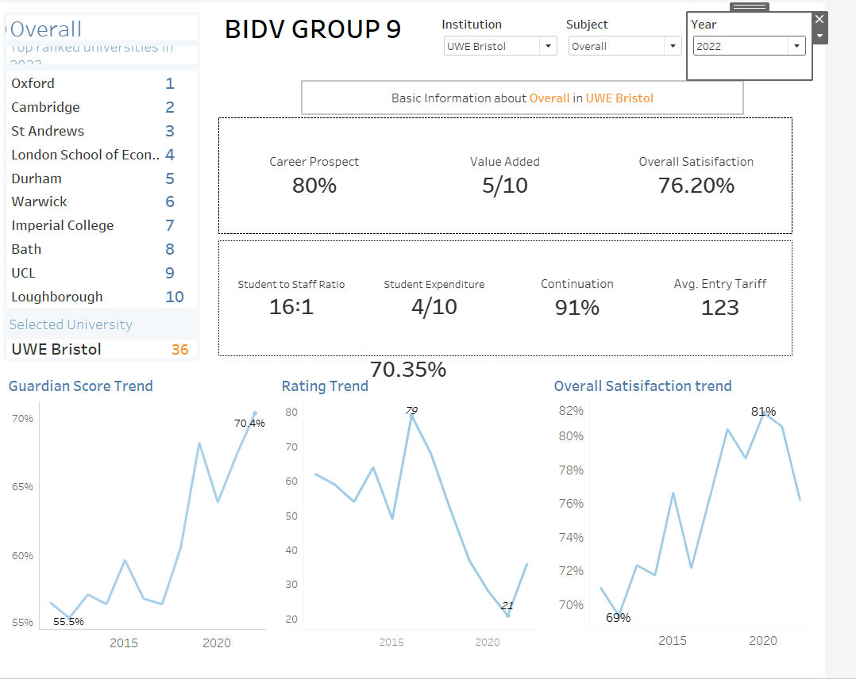

***Fig.8: Overall visualization for UWE guardian league Table***

**What are the characteristics of the data? Summarizing the data in various ways may help.**

The data summarizes university ratings across 12 years (2011-2022) using the Guardian ranking system.

|  |  |  |  |
| --- | --- | --- | --- |
|  | **Top 10 schools** | **UWE Bristol** | **Difference** |
| **Satisfied with Course** | **88.75** | **84.72** | **4.02** |
| **Satisfied with Teaching** | **87.97** | **86.52** | **1.45** |
| **Satisfied with Feedback** | **70.62** | **71.31** | **-0.69** |
| **Student to Staff Ratio** | **11.72** | **19.06** | **-7.34** |
| **Spend per Student** | **8.3** | **3.9** | **4.41** |
| **Average Entry Tariff** | **473.5** | **273** | **200.5** |
| **Value Added Score** | **6.21** | **6.7** | **-0.49** |
| **Career after 15 months** | **82.02** | **69.74** | **12.28** |
| **Continuation** | **96.97** | **90.92** | **6.05** |
| **Guardian Score** | **81.08** | **58.45** | **22.62** |

**8TH APRIL 2022 – MILESTONE 2 - UNDERSTAND THE BUSINESS REQUIREMENTS AND IDENTIFY STAKEHOLDERS.**

Businesses do not operate in a vacuum but rather in a dynamic environment that has a direct influence on how they operate and whether they will achieve their objectives. There are external and internal business environment. The external business environment is composed of numerous outside organizations and forces that we can group into seven key sub environments: economic, political and legal, demographic, social, competitive, global, and technological. Each of these sectors creates a unique set of challenges and opportunities for businesses and for the stakeholders that constitute the internal environments – entrepreneur, managers, workers, and customers (Brandell, 2016). In the context of the dataset adopted for this essay, therefore, the external environment of the UWE, Bristol includes the economic, political, legal, demographic, social, global, competitive and technological factors that either make or mar the achievement of the institution. For the purpose of this essay, the global and competitive external environment are crucial. This is because the dataset speaks of the global ranking of the UWE among other competing higher institutions of learning across the world. The internal environment of the UWE represented in the dataset of this essay comprises the stakeholders, which are identified in the next subsection.

**Identify the stakeholders**

The stakeholder is the:

* Vice Chancellor
* Staff
* Students

**8TH APRIL 2022 – TEEM MEETING**

The group had a meet on what business questions that could be used for personal and group data visualization. We had some questions which are:

1. Why has UWE ranked 70.35 (Guardian score) in the year 2022? And how has this differed from previous years.​
2. Why did UWE rank so poorly in the periods 2015-2016? ​
3. Have students been satisfied with teaching at UWE?​
4. Which subjects performed best in 2022?​
5. What subjects have the best teaching satisfaction and why?​
6. What subjects have the best course satisfaction and how has this differed from the worst? What variables have been the cause of this? ​
7. How have the top three studies subjects at UWE performed against its competitors ​

**9TH APRIL 2022 - What kind of questions they might need answered from the dataset?** I was able to come up with some business questions.

**BUSINESS QUESTIONS**

1. How has UWE been ranked in the Guardian league in the last 12years?

2. What is the average of UWE Bristol graduate getting jobs after 15 months?

3. What is the overall satisfaction with student-to-staff ratio?

4. How has UWE performed with its competitors?

5. What is the entry tariff of UWE Bristol?

6. Which of the top studied subjects performed best?

7. Which subject has the best teaching satisfaction?

**8TH APRIL 2022 – MILESTONE 3 – VISUALISE THE DATASET TO TRY AND ANSWER THE BUSINESS QUESTIONS**

**Question 1: How has UWE been ranked in the Guardian league in the last 12years?**

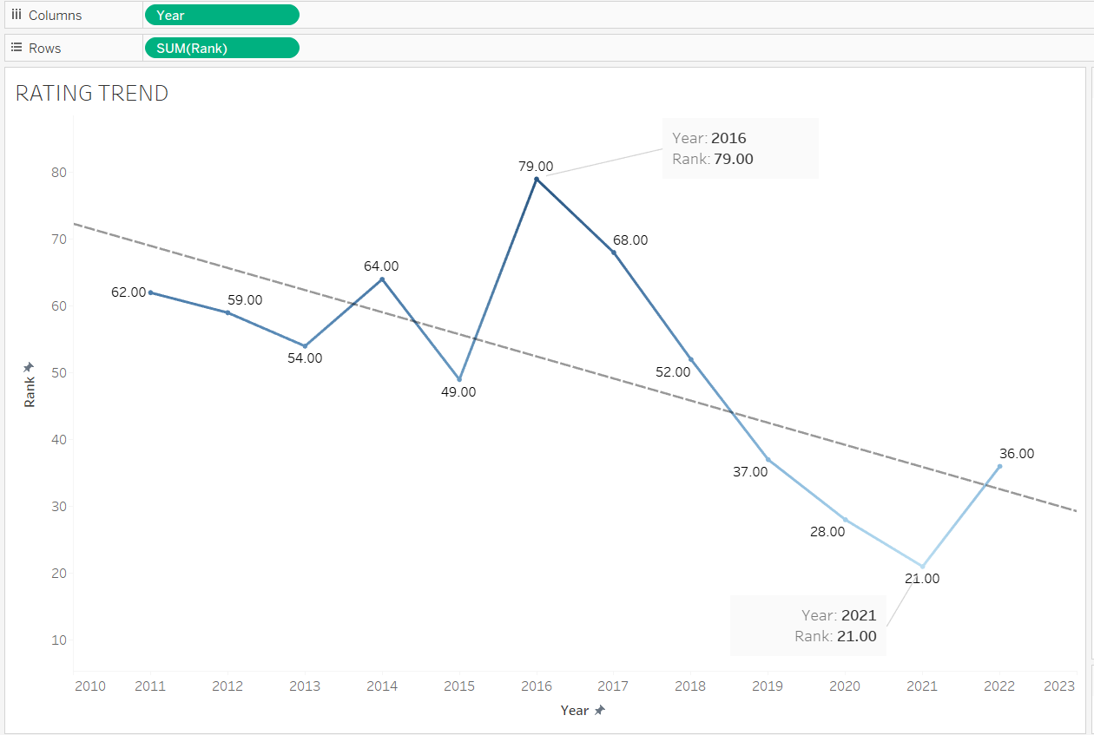

***Fig.9: UWE Bristol rating trend for 2011-2022***

From to the visualization above, UWE ranking was not stable from 2011 to 2016. The ranking witnessed a slight increase in 2012 and 2013, a slight decrease in 2014, a slight increase in 2015 and a huge decrease in 2016. Actually, in the year 2016, UWE has the lowest ranking in the dataset years as it ranked 79. Following year 2016, the UWE ranking started increasing until 2021 when it ranked 21. There is a slight decline in its ranking in 2022, however. This implies that the ranking of UWE over the last 12 years has not been that stable. In actual sense, it has been ranked low that it has been ranked high.

The vice-Chancellor of UWE Bristol, Professor Steve, said: “It’s rewarding to see the continued hard work of staff, students and the whole university community being recognised with our new position in the Guardian table (The Guardian, 2021) (UWE Bristol , 2022).

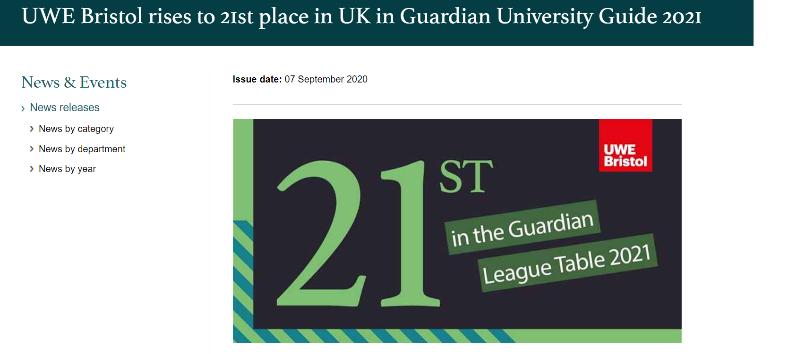

***Fig. 9b: UWE Bristol rank 21st in 2021***

**Question 2: What is the average of UWE Bristol graduate getting jobs after 15 months?**

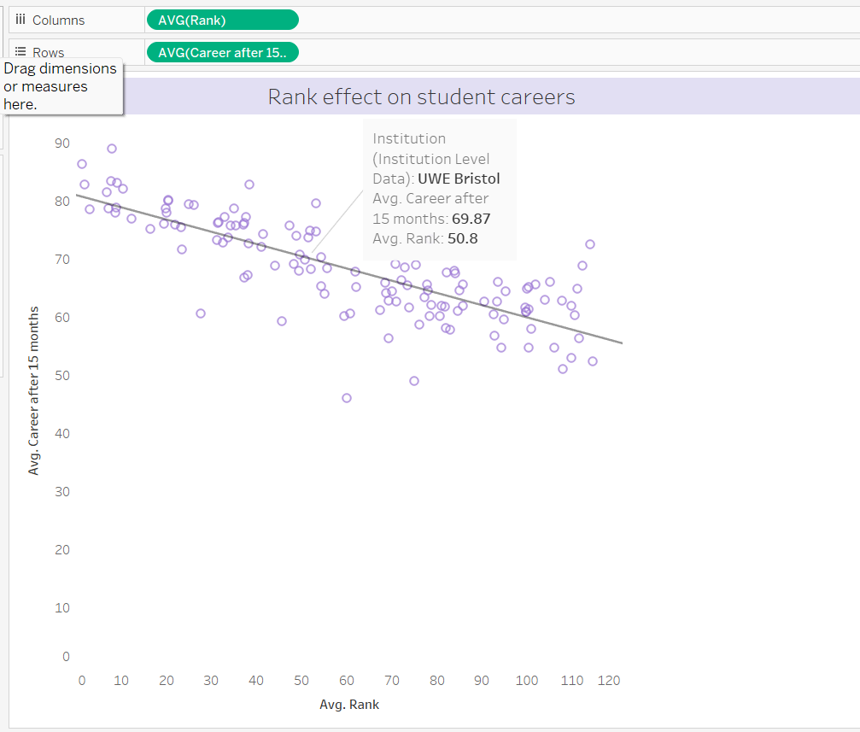

***Fig. 10: Average career after 15 months***

From the data visualization conducted, UWE was ranked an average of 50.8 in 2022, for the average of 69.87 graduate getting jobs after 15 months. This implies that close majority of the UWE graduate get job within 15 months of graduation. This has contributed to the overall ranking of the institution and specific ranking on the career prospects of the UWE students.

**Question 3: What is the overall satisfaction with student-to-staff ratio?**

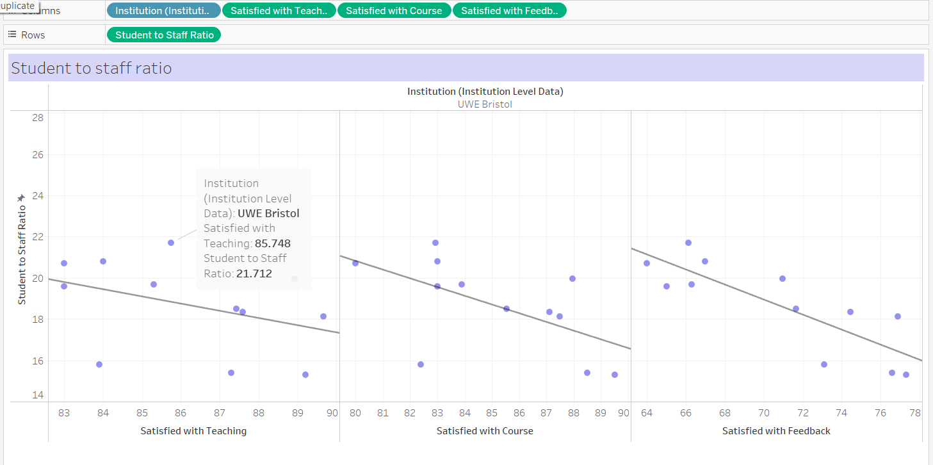

***Fig. 11: Overall student to staff ratio***

According to the visualization, the overall satisfaction with student-to-staff ratio is 21.712. This implies that the data yielded an average of 21.712 satisfaction with the ratio of staff to students at the UWE. In essence, this satisfaction level is way below expectation and this shows that the internal environment (Stakeholder – staff and students inclusive) of the UWE demands adequate and urgent attention. This is because of the crucial role they can play in making or marring the global ranking of the institution.

**Question 4: How has UWE performed with its competitors?**

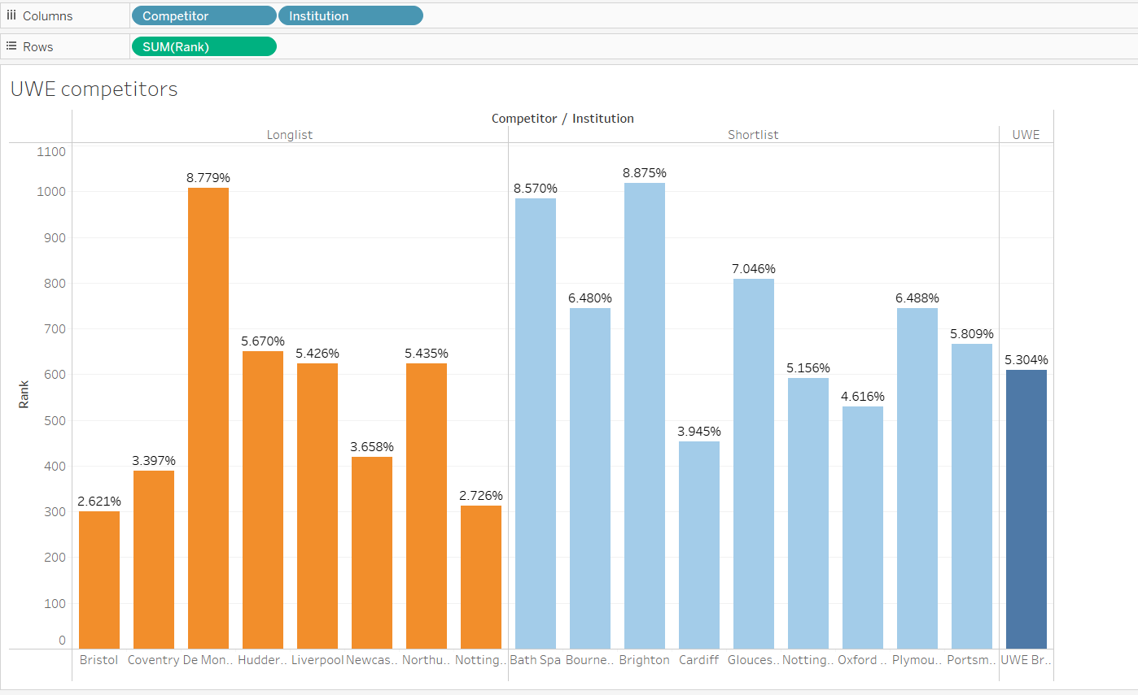

***Fig. 12: Performance of UWE with competitors***

Among the longlist competitors, UWE Bristol was ranked least with 2.621%. However, in the shortlist competitors, UWE Bristol was ranked 5.304% and this was only higher than Nottingham (5.156%), Oxford (4.616%) and Cardiff (3.934%) while other shortlist competitors were ranked higher than the UWE Bristol with the Brighton topping the list with 8.875%. This implies that it was only in the shortlist competitors that UWE Bristol was ranked higher than three institutions. By implication, UWE Bristol has not really performed well with its competitors both on the longlist and the shortlist.

**Question 5: What is the entry tariff of UWE Bristol?**

Average entry tariff is the credit or qualification a student obtained before joining the subject in the university

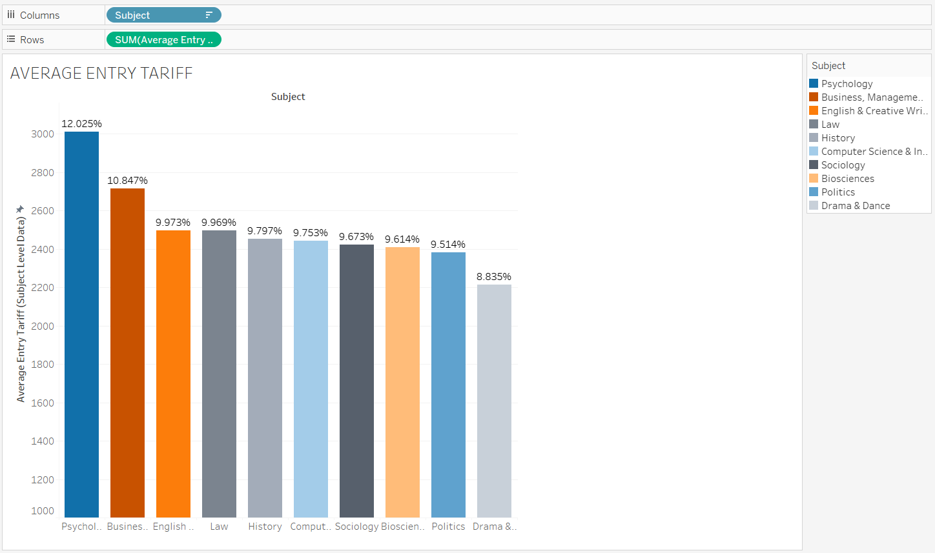

***Fig. 13: Average entry tariff***

The visualization indicates that the Psychology entry tariff was the highest with 12.025% which the entry tariff of Drama and dance was the lowest with 8.835%. This implies that psychology seems to be the most opted for among the listed subjects followed by Business management, English & Creative Writing, Law, History, Computer Science, Sociology, Biosciences, and Politics, while Drama and dance was the least opted for. In this visualization above the color-blind color was adopted to different each subject from one another.

**Question 6: Which of the top studied subjects performed best?**

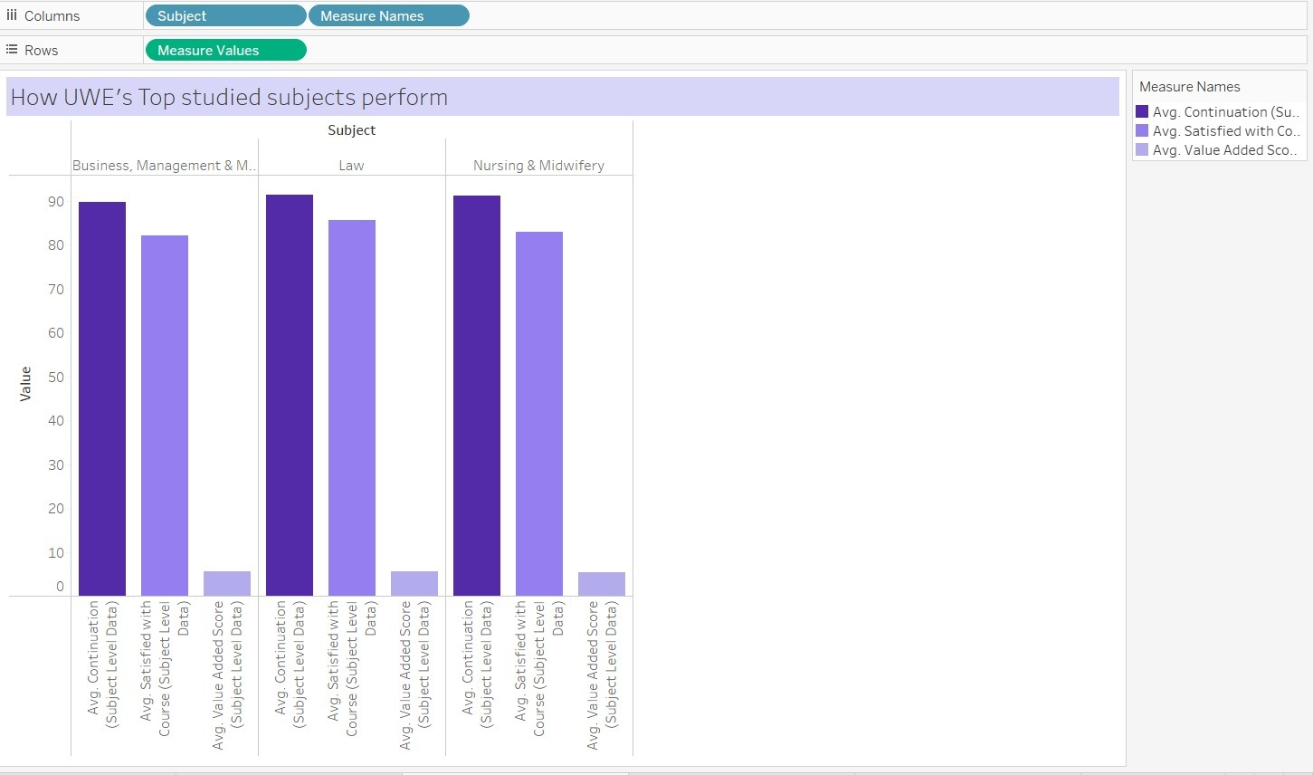

***Fig. 14: Top subject performance***

Among the three (Business management, law and nursing) top studied subjects, law was the top studied subject that performed best in terms of average continuation, average satisfaction and average value-added score. This implies that Law as a subject mostly enjoyed students' continuation and mostly elicited students’ satisfaction, because it has the greatest added value among other factors.

**Question 7: Which subject has the best teaching satisfaction?**

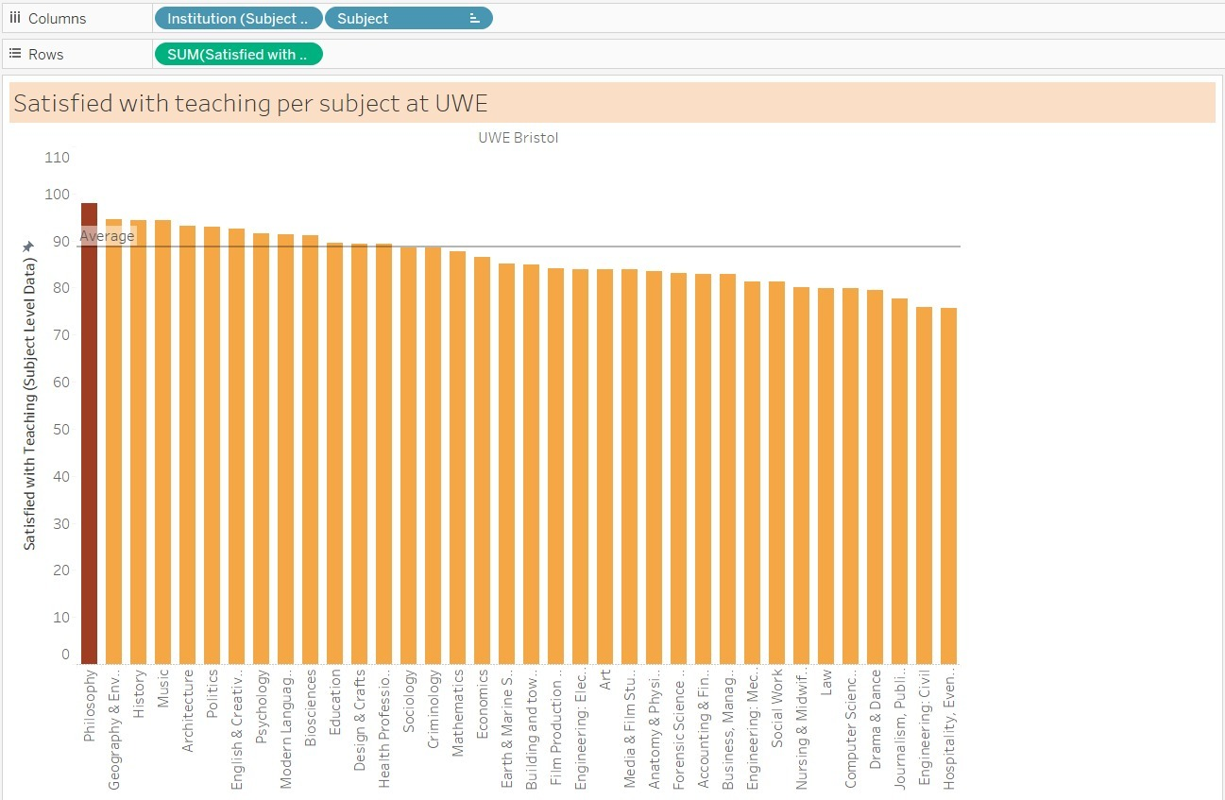

***Fig. 15a: Best subject teaching satisfaction (appropriate)***

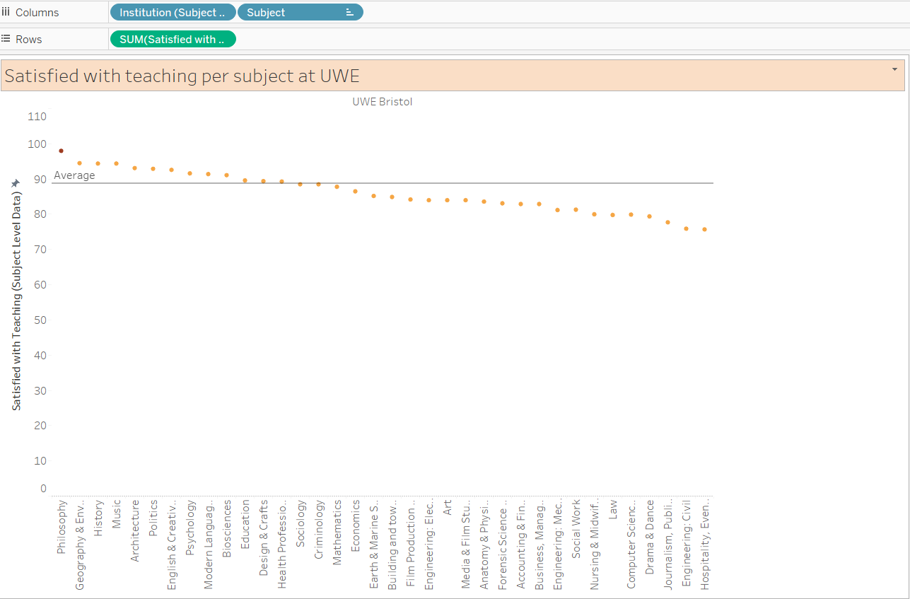

***Fig. 15b: Best subject teaching satisfaction (inappropiate)***

Averagely, Philosophy is the subject with the highest teaching satisfaction while Hospitality is the subject with the least teaching satisfaction. This implies that in all of the subjects offered at the UWE Bristol, Philosophy is the subject students were most satisfied with its teaching while Hospitality is the subject with the least students’ satisfaction in terms of teaching.

The bar chart was used to visualize the data rather than using a line graph because the line graph did not give appropriate visualization for the data. I also different the highest subject from the others.

**Further visualizations are as follows:**

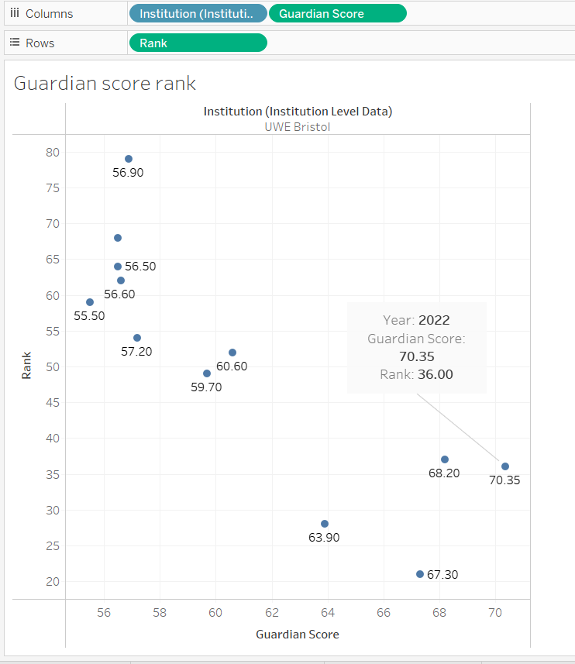

***Fig. 16: Guardian ranking score***

The screen shot show how UWE has ranked over the years. In 2022 it was ranked 36th and the guardian score is 70.35.

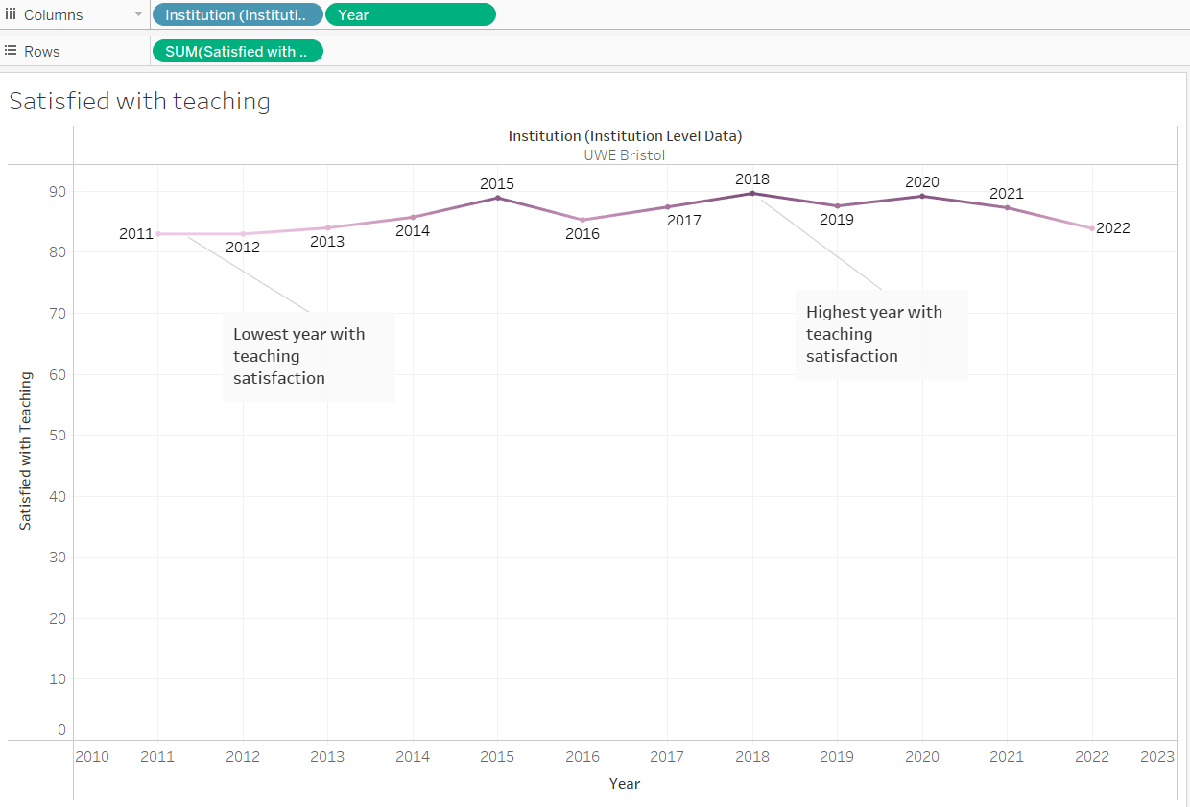 ***Fig. 17: Yearly rank of satisfied with teaching***

The screenshot shown above (***Fig. 17***) depicts an unstable progression trend of teaching satisfaction. It shows the year with the highest and lowest satisfaction based on teaching in UWE Bristol and also, it shows that 2011 and 2012 were the lowest year with teaching satisfaction.

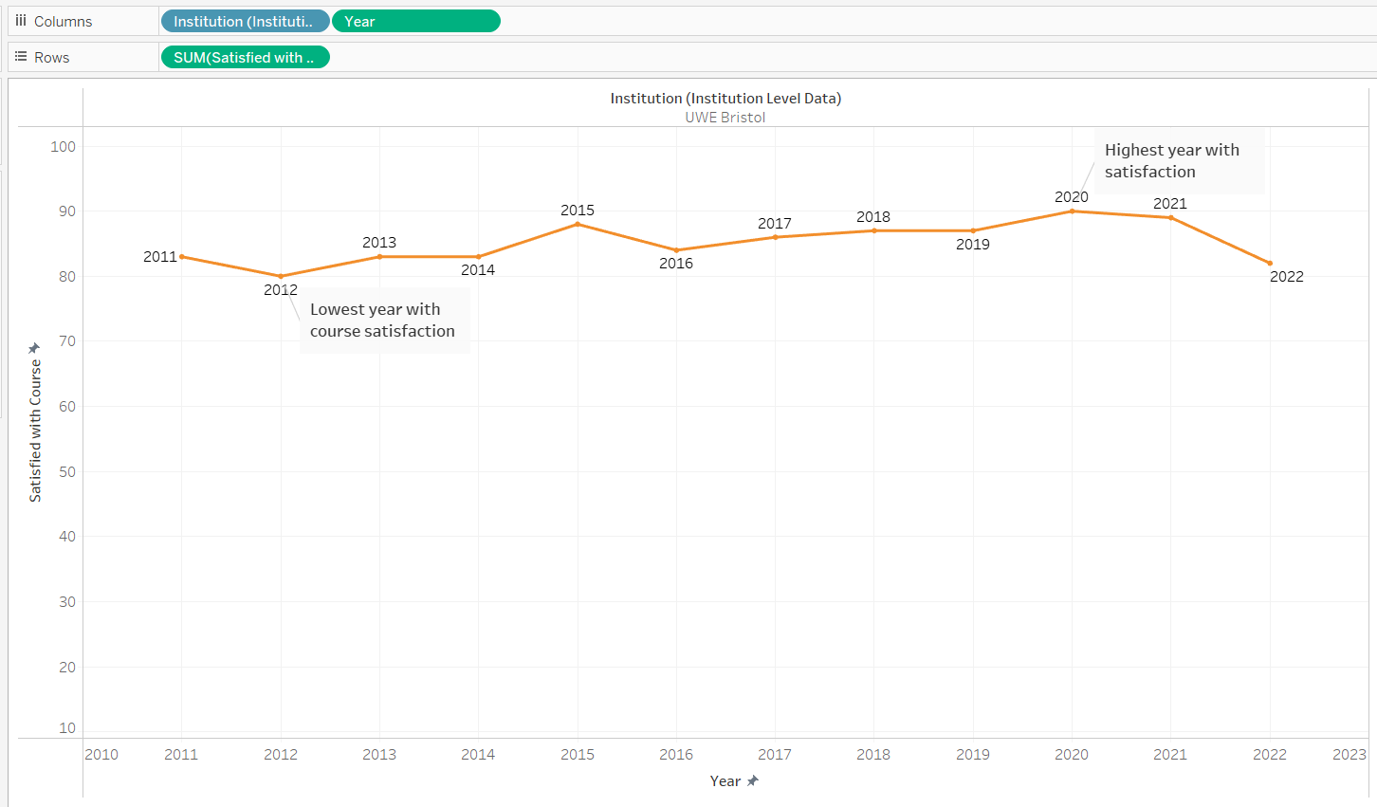

***Fig. 18: yearly rank of satisfied with courses***

The Figure above shows how student are satisfied with the courses yearly

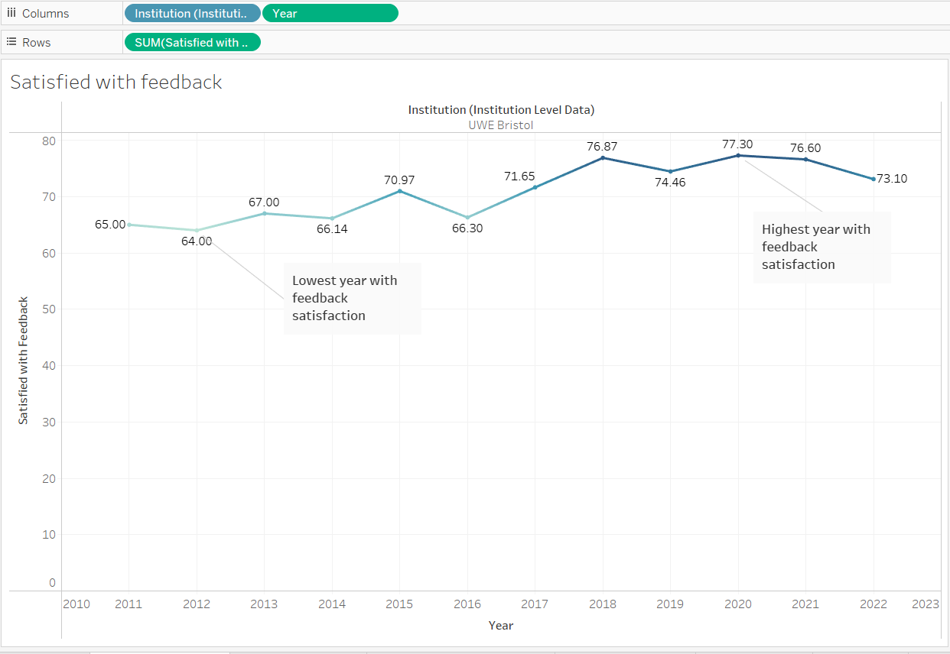

***Fig. 19: Yearly rank of satisfied with teaching***

Figure 19 shows how the institution is satisfied with the feed back form 2011-2022. I use the blue color here because its one of the color-blind color and also to differentiate it from other satisfaction

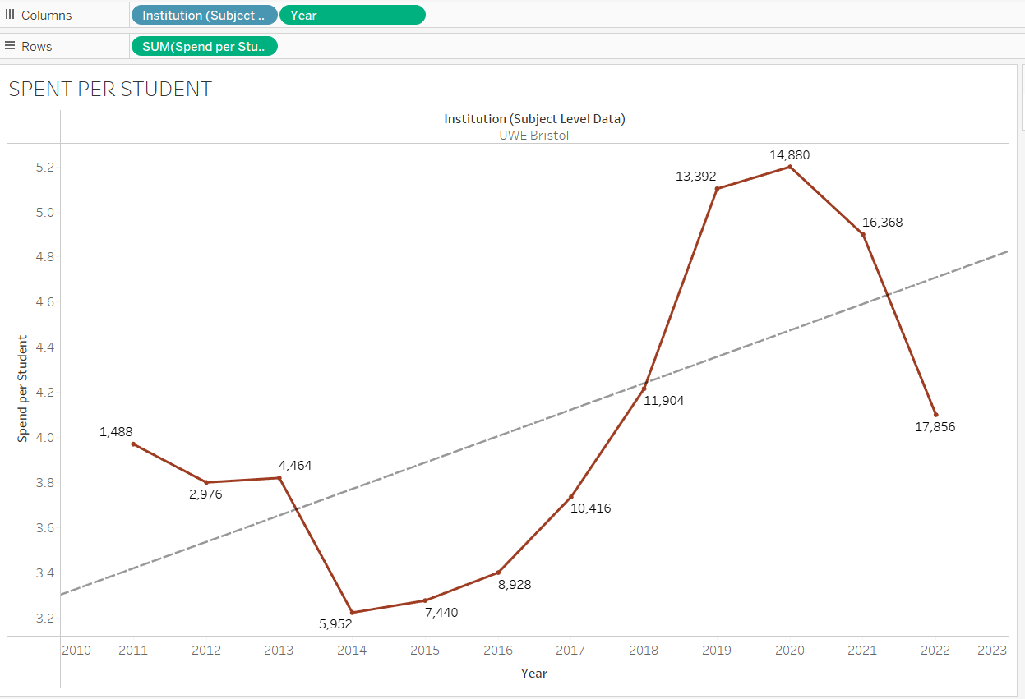

***Fig. 20: Spend per student yearly***

This shows how student spend on a yearly basis. I used the red color here because it represents UWE’S logo. The highest year spent was in 2020

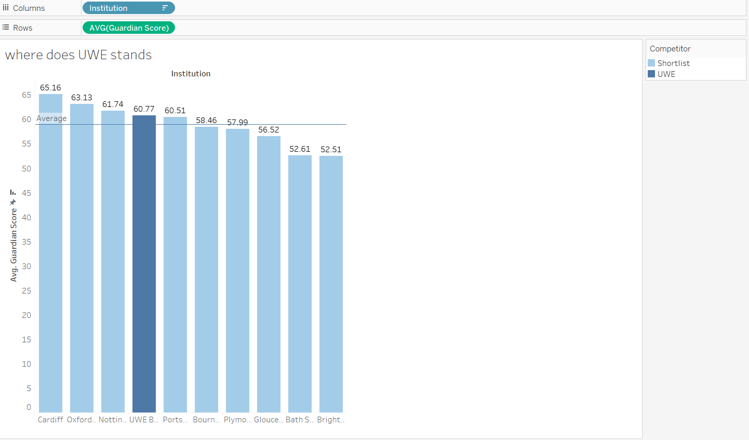

***Fig.21a: Average guardian score of UWE and Shortlist competitor***

This shows the how UWE has performed averagely in the guardian league table.

I watched a video on how to insert the average line in Tableau.

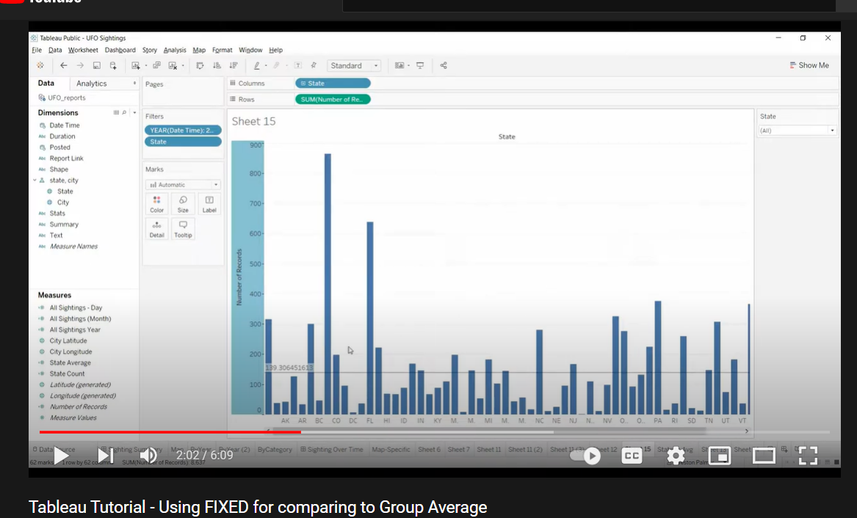

***Fig. 21b: How to fix the average line in tableau***

**15 APRIL 2022 - MILESTONE 4 – DEVELOP A NARRATIVE TELLING A STORY AROUND THE DATA**

The figures below show the story around the data

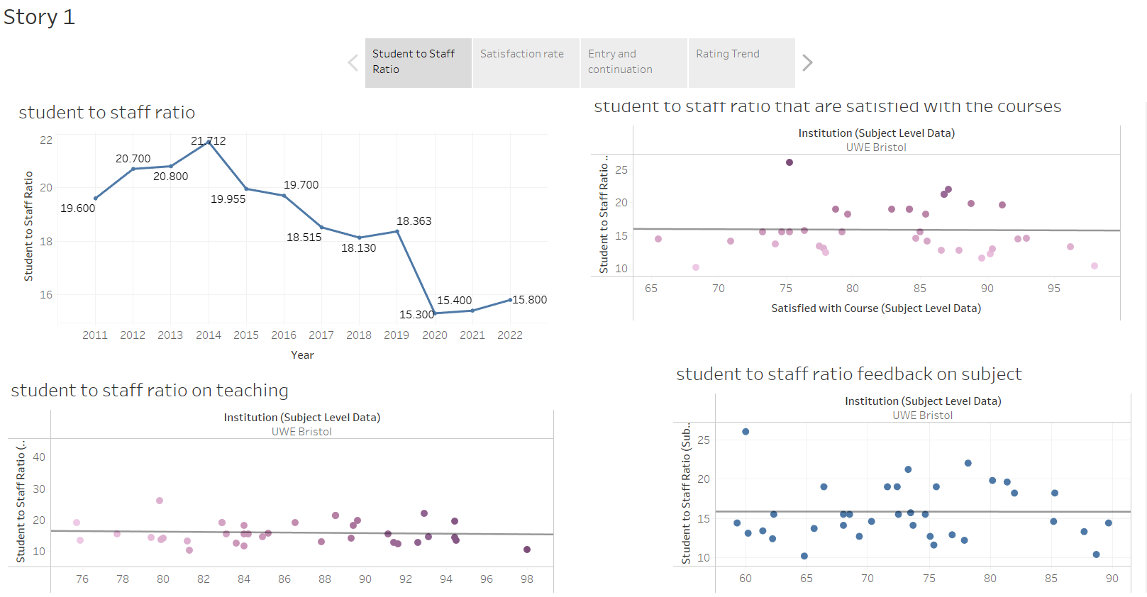

***Fig. 22a: Student to staff ratio***

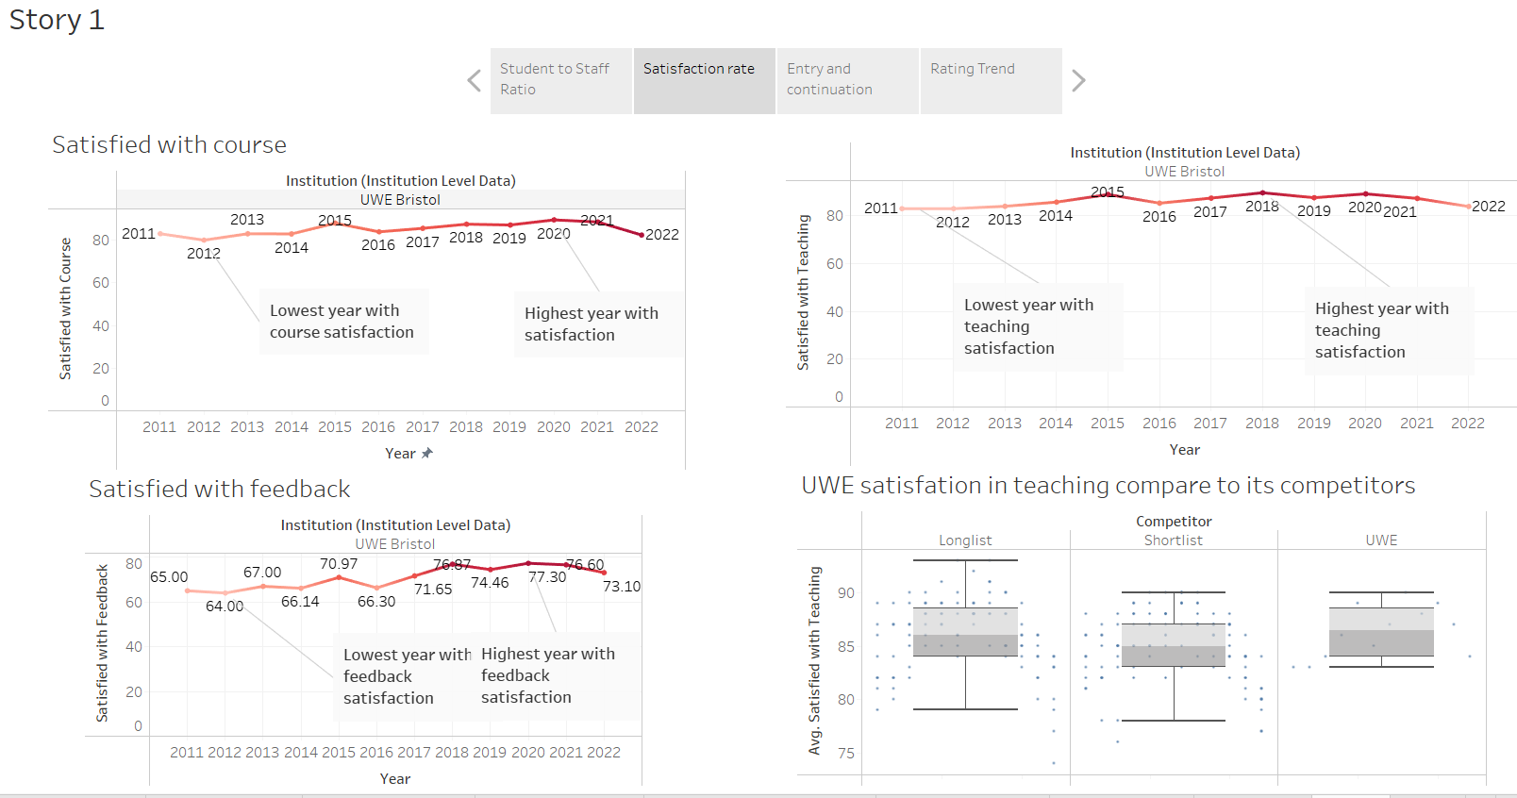

***Fig 22b: Satisfaction rate***

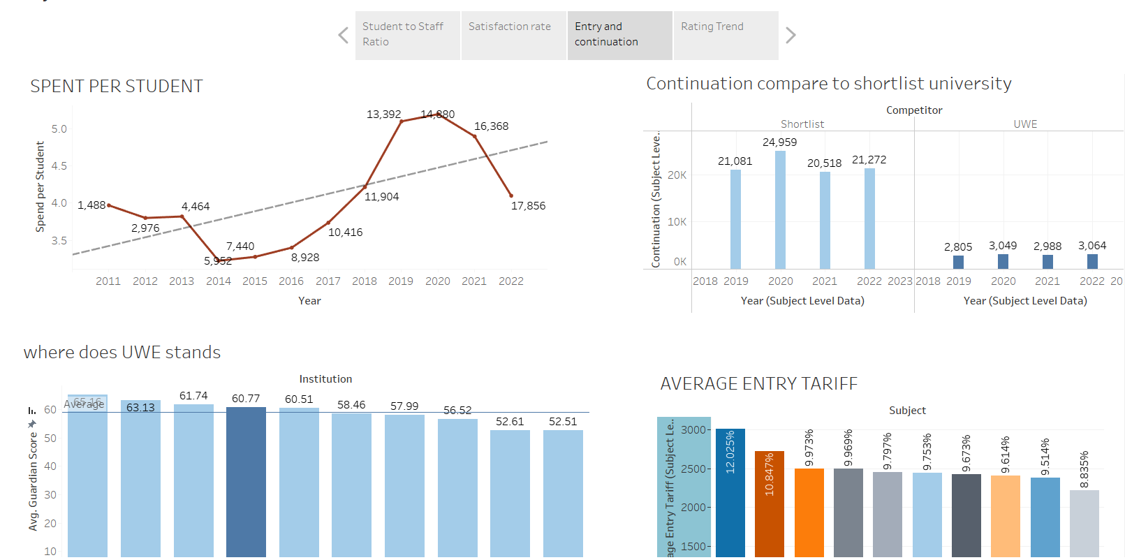

***Fig 22c : Entry and continuation***

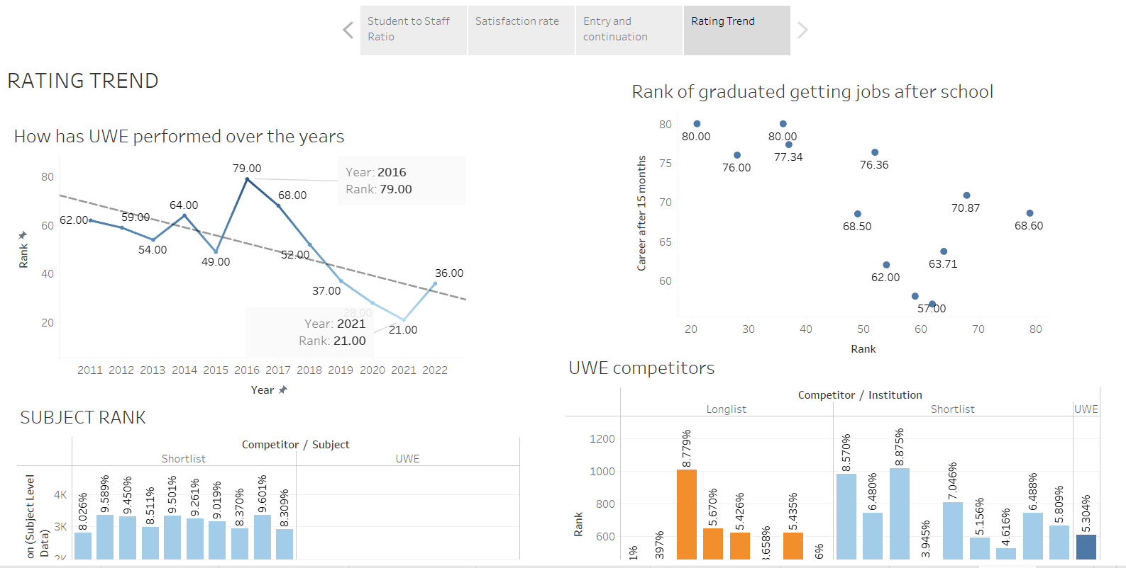

***Fig 22c: Rate trend***

Through the creation of my dashboard, I was able to show the relationship between student to staff ratios and how satisfied students are with teaching, feedback, and courses over the course of the year. Teaching feedback and courses are related to teacher satisfaction. As a result of the satisfaction, you can also determine if people intend to continue taking the course, refer people to the school for admission, or if you do not want the course to continue.

**20TH APRIL 2022 – IDENTIFY RECOMMENDATIONS FOR FUTURE IMPROVEMENTS AND ENHANCEMENTS**

The following are recommendations made for UWE to improve its position and/or ranking in the future:

* UWE management team should conduct a review study on the strengths of the institution in 2021 when it received it highest ranking so far and the weaknesses of the institution in 2016 when it received it lowest ranking so far. The result of this review of strengths and weaknesses will enable the institution to plan adequately for future competitive ranking.
* UWE career development unit should work closely with graduates of the institution who are yet to get jobs even after 15 months so as to study the possible causes of the joblessness and how the institution can use its curriculum and academic programmes to resolve it or reduce it to a barest minimum.
* UWE should pay adequate and urgent attention to its staff and students’ ratio by making it globally acceptable and more importantly satisfactorily with the students.
* UWE should study its major competitors and design offers that are way better than theirs.
* UWE academic planning and quality assurance unit should review teaching performance of year 2018 and task teaching staff to adopt the teaching models and styles used at that time.
* Teaching staff across all subject areas in UWE should be encouraged to embrace personal and professional development that will enhance their teaching skills and motivate students to learn their individual chosen subject to their satisfaction.

**25TH APRIL 2022 - 3RD INDUSTRY ADVISOR MEETING**

This is an overall discussion with Dan and the module leader Haixia on the reflective diary. I asked question about continuation and he said it was introduced to the League table a few years ago. It measures the number of students that sticks around any institution for at least one year. From the data set, continuation has some missing values from year 2012- 2017.

**26TH APRIL 2020 – MORE DATA VISUALIZATION PRATICE**

I was able to understand more continuation and did practice around the data

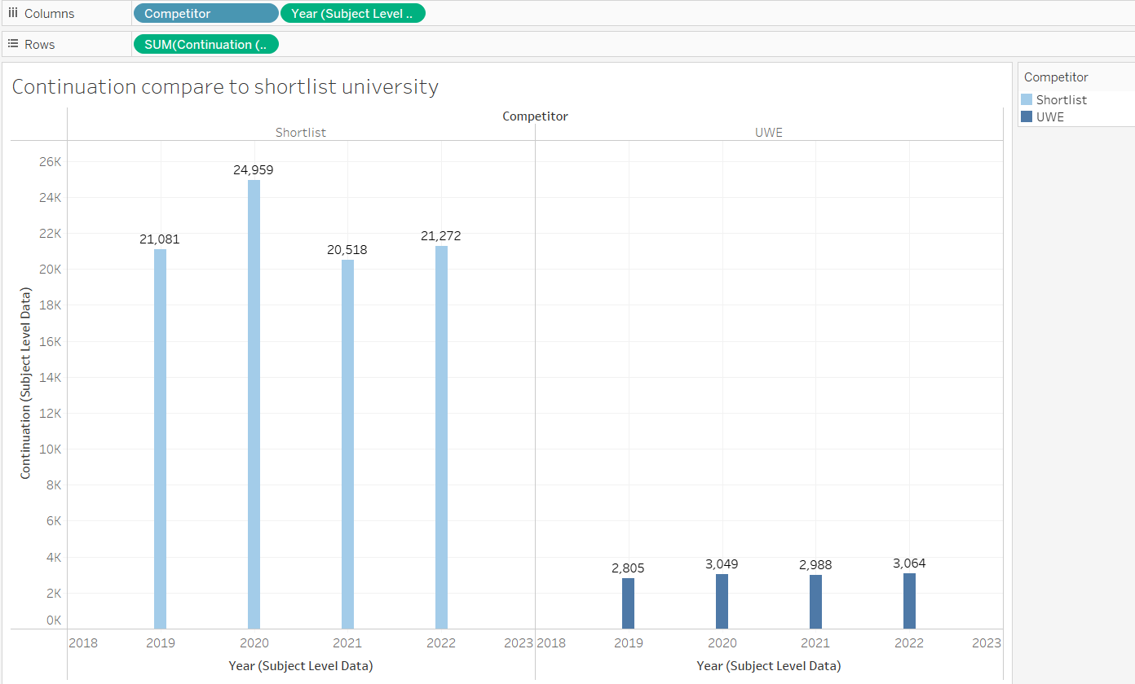

***Fig. 23: Continuation in UWE compared to shortlist university***

This figure shows the continuation of student in each university.

**2ND MAY 2022 - CHALLENGES AND LIMITATIONS**

The processes of accessing the data and visualising them in line with the focus of my essay presented some challenges. Among these challenges was the rigor of visualising the data in Tableau, despite the fact that Tableau remains the number one analytical tool in data visualisation. During the visualisation process, the tool presented the challenge of an absence of scheduling options. That implies that I could not get the option of refreshing with the help of automatic scheduling. Since there is no scheduling option in Tableau, I must then manually refresh than automatically refresh.  However, this did not so much affect the process, as I took my time to refresh manually every necessary time. Therefore, the use of Tableau for the visualisation was both rigorous and time consuming. Similarly, the use of Tableau for the visualisation also was challenging because it is not a completely open platform and also I had to consider people with eye problem by using the color-blind colors. In other visualization tools such as Power BI, developers can import the visuals rather than recreating them. However, in Tableau, one must recreate the visuals rather than importing. So, it takes time to recreate.

**REFERENCES**

Brandell, B., 2016. *Business 2 Community "What is business process Management".* [Online] Available at: https://www.business2community.com, [Accessed 15 March 2022].

Helpfolder, 2016. *Youtube.* [Online] Available at:https://www.youtube.com/watch?v=8M438DRiaZs [Accessed 16 February 2022].

Oliver, P. M. C. S. R. C. M., 2019. The impact of signal pre-processing on the final interpretation of analytical out. *Analytica Chimica,* 1058(doi:10.1016/j.aca.2018.10.055. PMID 30851858. S2CID 73727614), pp. 9-17.

Palmer, W., 2018. *Youtube.* [Online] Available at: <https://www.youtube.com/watch?v=vDpFiR-NBoM> [Accessed 29 March 2022].

Pavan, L., 2018. *Youtube.* [Online] Available at: <https://www.youtube.com/watch?v=AcgnPrK9dxk> [Accessed 16 February 2022].

Pyle, D., 1999. *Data Preparation for Data Mining ,* Los Altos California: Morgan Kaufmann

Rasulov, Z., 2021. Missing values in Data Science. *Analytics Vidhya.*

The Guardian, 2021. *The Guardian.* [Online] Available at: <https://www.theguardian.com/education/2021/sep/11/how-to-use-the-guardian-university-guide2022#:~:text=The%20Guardian%20score%2C%20out%20of,students%20in%20the%20latest%20NSS>. [Accessed 19 FEBRUARY 2022].

UWE Bristol , 2022. *UWE Bristol rises to 21st place in UK in Guardian University Guide 2021.* [Online] Available at: <https://info.uwe.ac.uk/news/uwenews/news.aspx?id=4066>

[Accessed 12 March 2022].